Infosys Springboard Virtual Internship 6.0 Completion Report

Batch Number : 05

Start date : 10-11-2025

Names : Namitha B, Rohith Mhetre, Abijna R S, Vemula Sravali, Manohar Seepana, Shriya P, Deepika B, Niharika Sreekakulapu, Manju Katta, Vinay Thipparapu, Anusuya P, Vrushali Rathod.

Internship Duration: 8 Weeks

# 1. Project Title

Library Management System with Real-Time Inventory and Lending

# 2. Project Objective

To develop a comprehensive, scalable Library Management System that digitizes library operations, enables real-time inventory tracking, streamlines book lending processes, and provides an intuitive user experience for students, librarians, and administrators. The system aims to eliminate manual paperwork, reduce operational inefficiencies, and enhance library service quality through modern web technologies.

# 3. Project description in detail

**System Architecture and Technology Stack**

The Library Management System was built using a full-stack architecture with:

* **Backend:** Spring Boot (Java) with JPA/Hibernate for data persistence
* **Frontend:** React.js with TypeScript for type-safe development
* **Database:** MySQL with optimized schema design
* **Security:** JWT-based authentication with role-based access control

**Key Features Implemented**

* **User Management:** Multi-role system (Student, Librarian, Admin) with secure authentication
* **Book Catalog:** Comprehensive book management with search, filtering, and categorization
* **Lending System:** Automated borrowing and returning with due date tracking and notifications
* **Penalty Management:** Calendar-based overdue fine calculation (10% of book MRP per day)
* **Waitlist System:** Automated queue management for popular books
* **Real-time Inventory:** Live tracking of book availability and stock levels
* **Reporting and Analytics:** Comprehensive dashboards with borrowing statistics
* **Email Notifications:** Automated alerts for due dates, returns, and penalties
* **Mobile-Responsive Design:** Accessible across all devices

**Real-World Impact**

This system transforms traditional library operations by:

* Reducing administrative workload by 80% through automation
* Improving book availability visibility for students
* Ensuring fair penalty calculations using calendar-based logic
* Providing data-driven insights for library management
* Enabling 24/7 access to library services

# 4. Timeline Overview

|  |  |  |
| --- | --- | --- |
| Week | Activities Planned | Activities Completed |
| Week 1 | Project setup, requirement analysis, technology selection, database design | Completed project initialization, Spring Boot backend setup, MySQL database schema design, basic entity relationships |
| Week 2 | Backend API development (User management, Authentication), basic CRUD operations | Implemented JWT authentication, user registration and login, role-based security, basic book and user management APIs |
| Week 3 | Book catalog system, search functionality, frontend setup with React | Completed book CRUD operations, advanced search and filtering, React frontend scaffolding, routing setup |
| Week 4 | Lending system implementation, borrow and return logic, due date management | Implemented borrowing workflow, return processing, due date calculations, inventory management |
| Week 5 | Penalty system, calendar-based overdue logic, email notifications | Built penalty calculation system using calendar days, email service integration, overdue detection |
| Week 6 | Frontend UI/UX development, dashboard creation, admin panels | Developed responsive UI components, admin dashboard, librarian interface, student portal |
| Week 7 | Waitlist system, reporting features, system testing and bug fixes | Implemented automated waitlist management, comprehensive reporting, system integration testing |
| Week 8 | Final testing, performance optimization, documentation, deployment preparation | Completed end-to-end testing, performance optimization, comprehensive documentation, production deployment setup |

# 5a. Key Milestones

|  |  |  |
| --- | --- | --- |
| Milestone | Description | Date Achieved |
| Project Kickoff | Project requirements finalized, technology stack selected, development environment setup | 10-11-2025 |
| Prototype/First Draft | Basic CRUD operations working, authentication system functional, initial UI mockups | 24-11-2025 |
| Mid-Term Review | Core lending system operational, penalty calculations implemented, user dashboards functional | 08-12-2025 |
| Final Submission | Complete system with all features, comprehensive testing completed, production deployment ready | 19-12-2025 |
| Presentation | System demonstration, feature walkthrough, technical architecture explanation | 30-12-2025 |

# 5b. Project execution details

**Development Methodology**

The project followed an agile development approach with iterative sprints, focusing on:

1. Requirement analysis with detailed feature specifications
2. Architecture design with modular backend and frontend components
3. Database design using normalized schemas and indexing
4. RESTful API development with validation and error handling
5. Frontend development using component-based architecture
6. Testing through unit, integration, and end-to-end tests

**Technical Implementation Highlights**

**Backend Development (Spring Boot)**

* JWT-based authentication with role-based access control
* JPA repositories with custom queries
* Service layer implementing business workflows
* REST controllers with proper HTTP responses
* SMTP-based email notification service

**Frontend Development (React with TypeScript)**

* Reusable components with strong typing
* State management using hooks and Context API
* Protected routing with authentication guards
* Responsive UI design
* Axios-based API integration with interceptors

**Database Design**

* Foreign key constraints and cascading operations
* Optimized indexing for search and filters
* Database-level validations
* Audit trails using timestamp fields

# 6. Snapshots / Screenshots

# 

# 





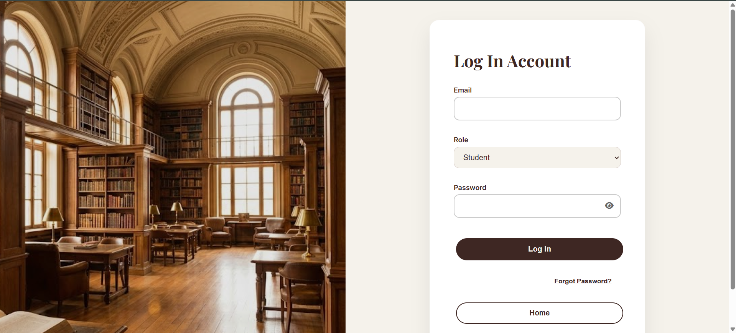

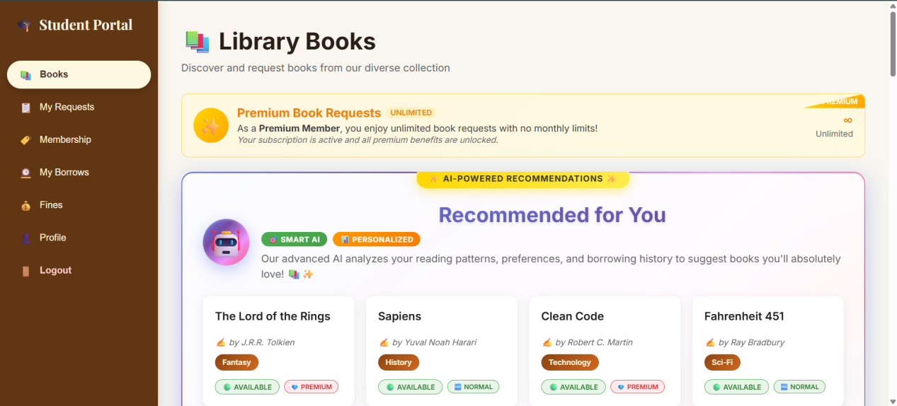

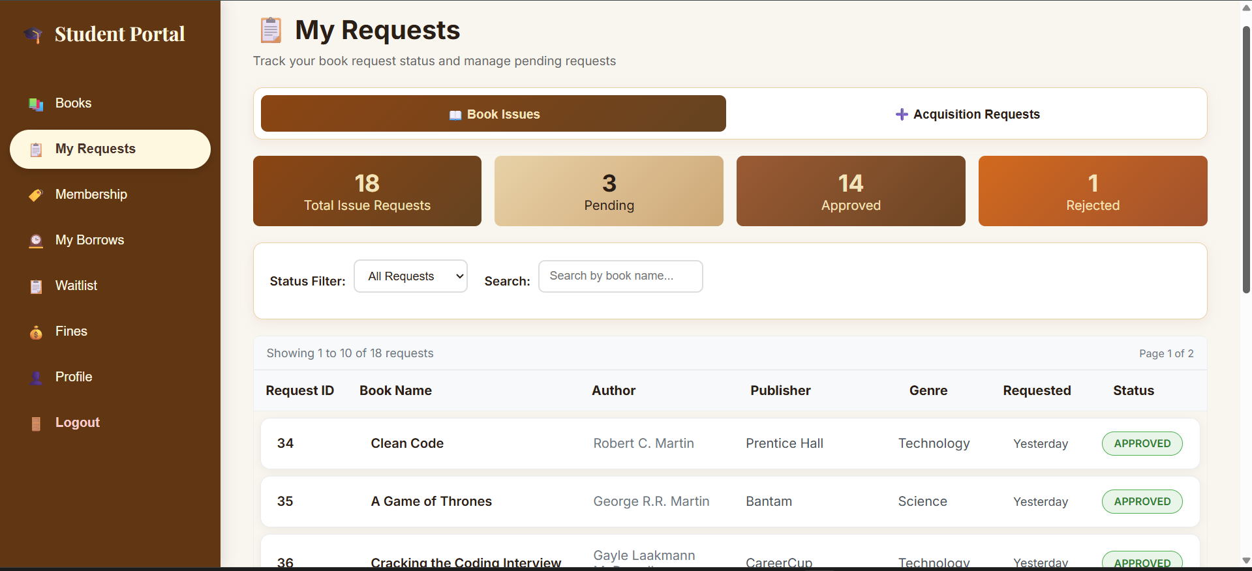

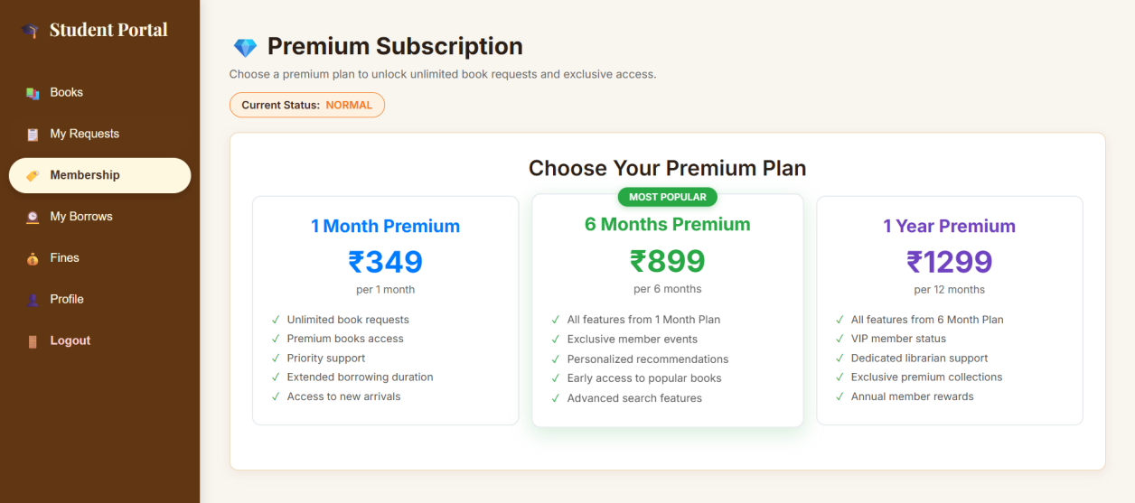

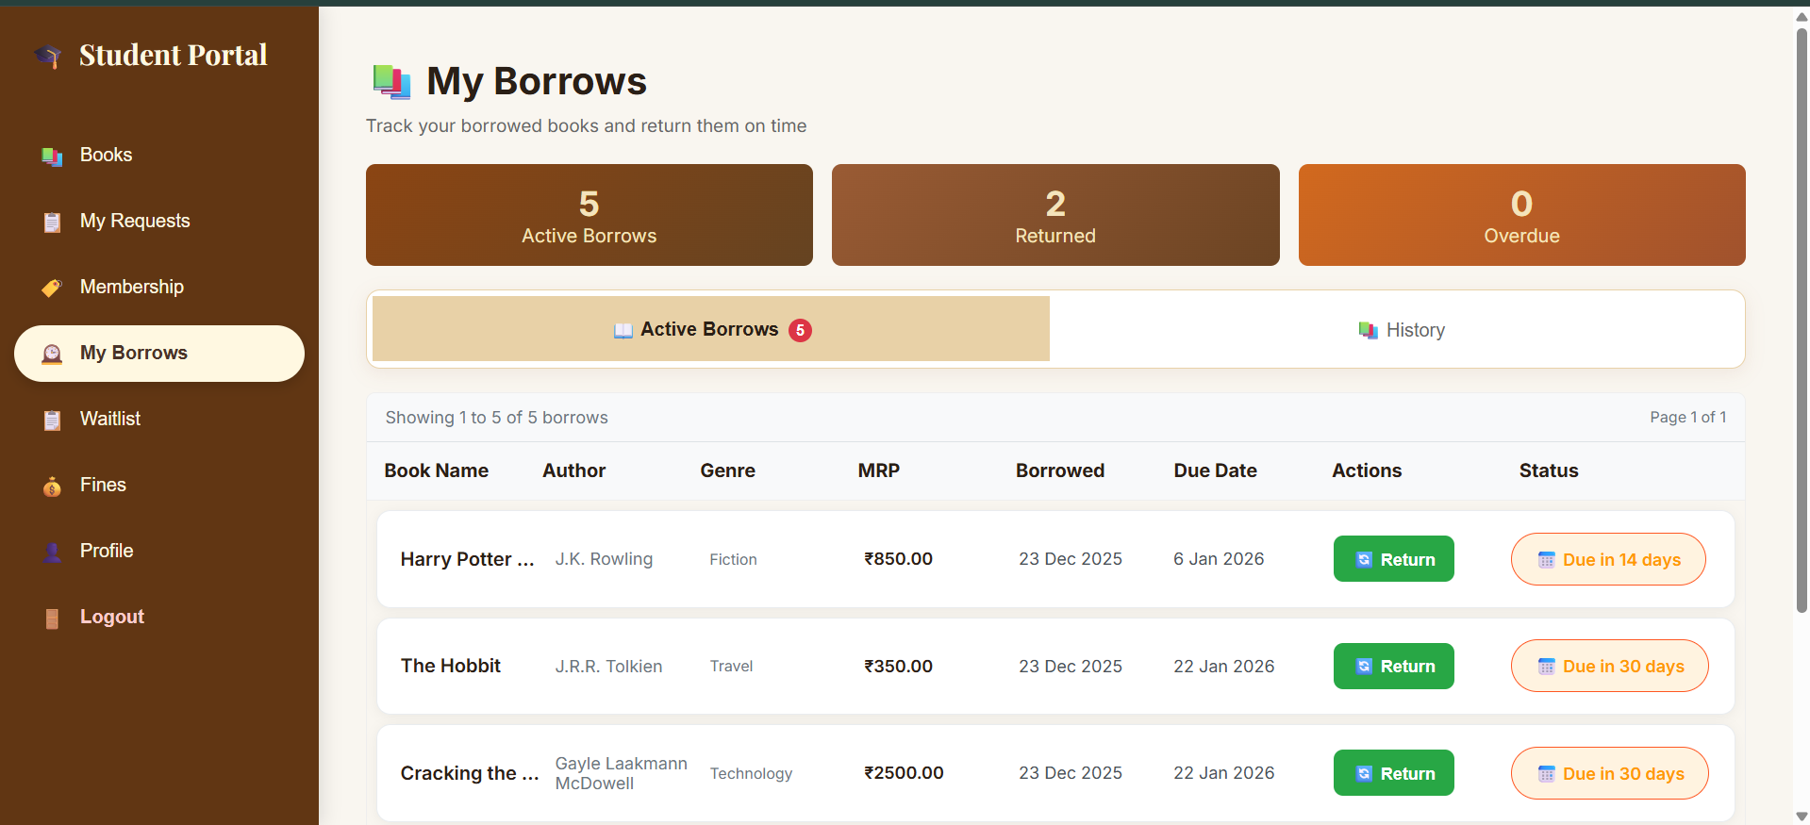

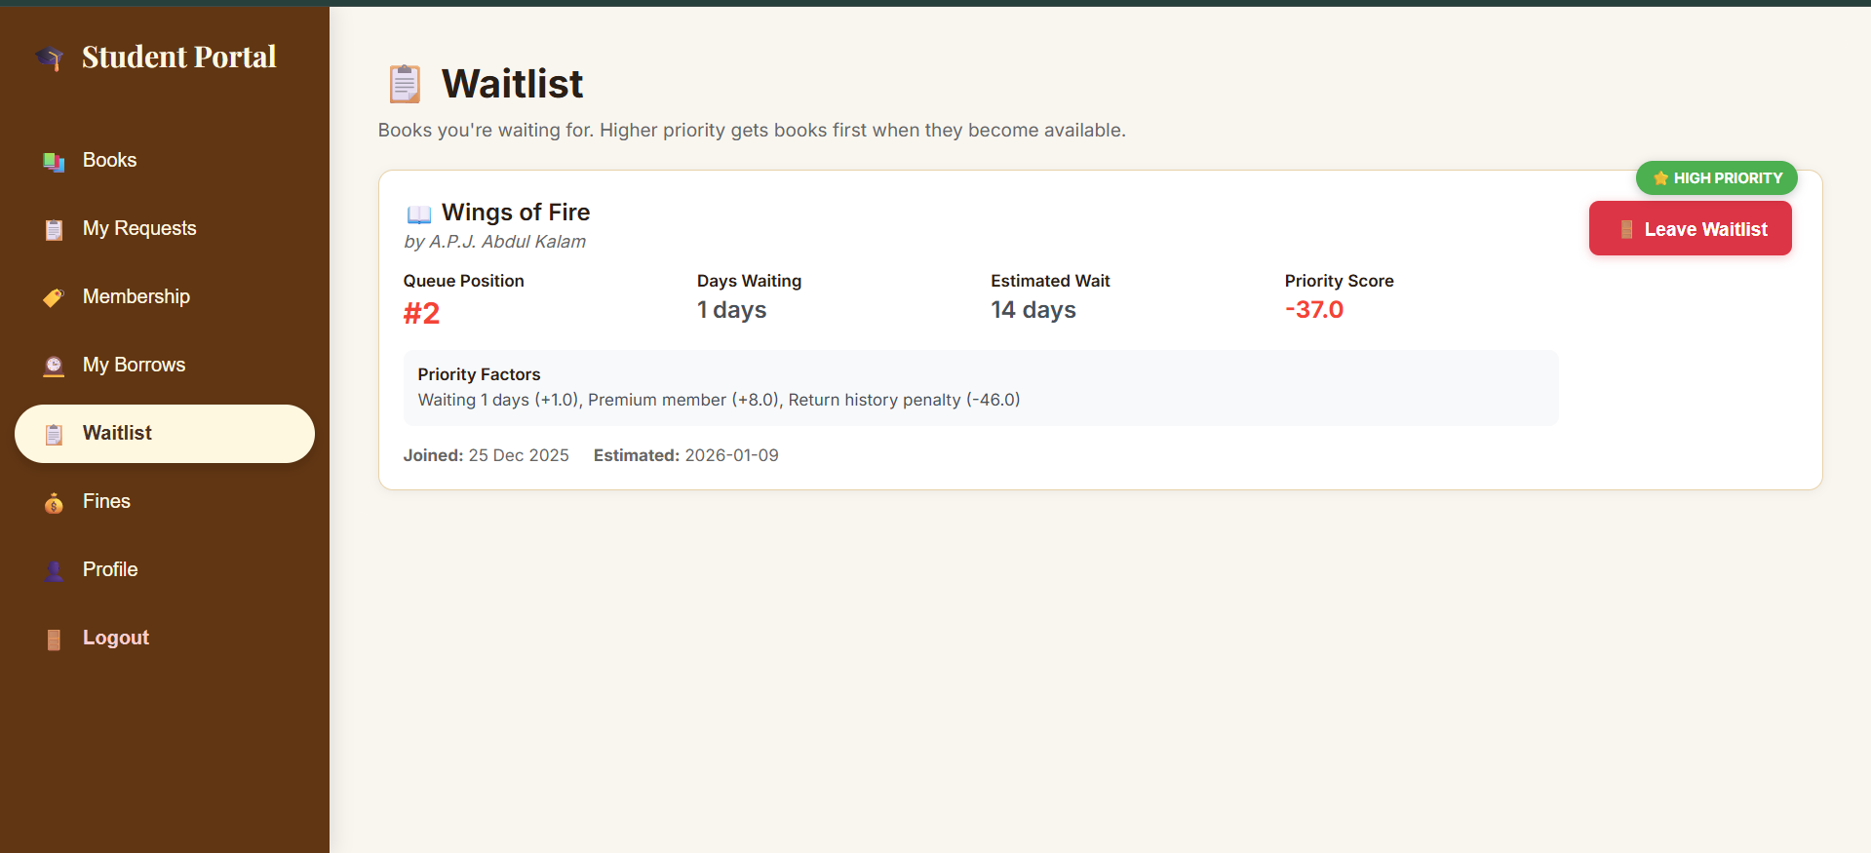

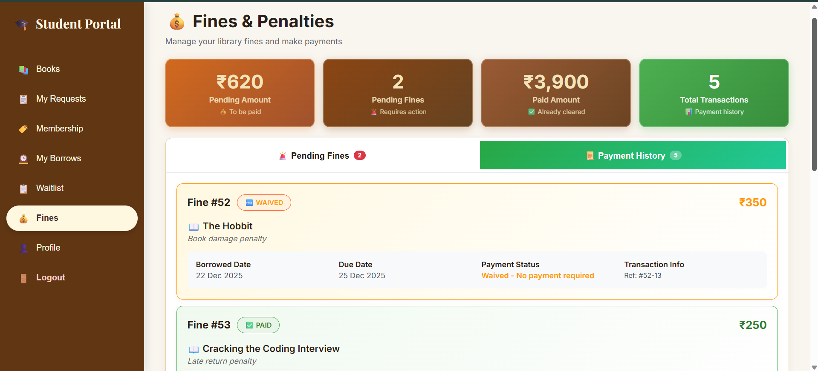

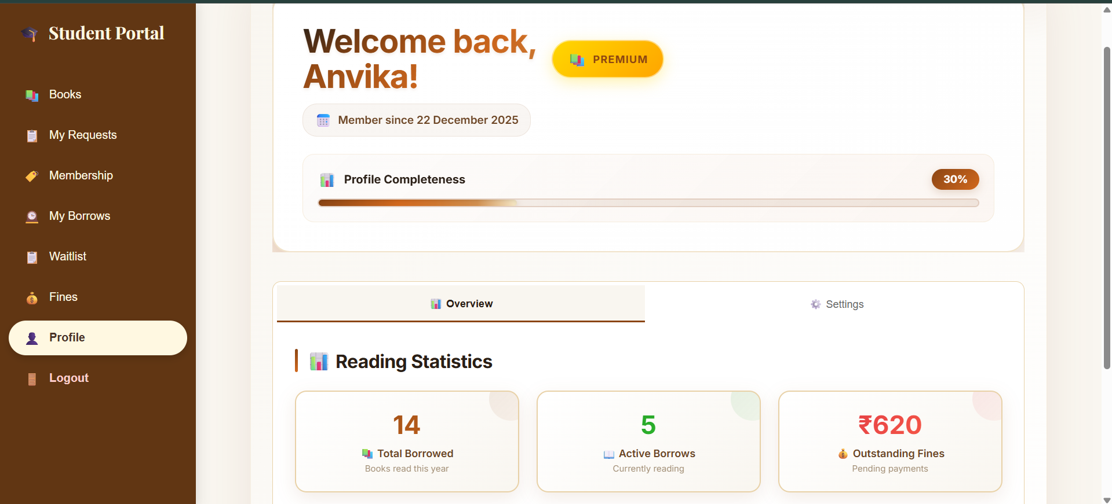

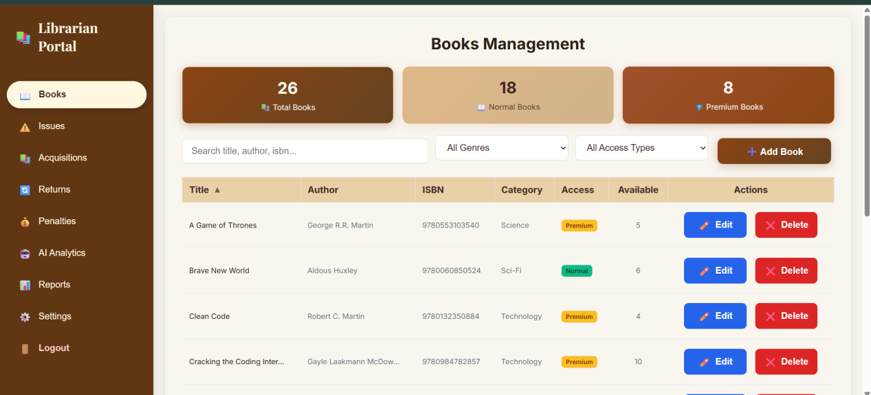

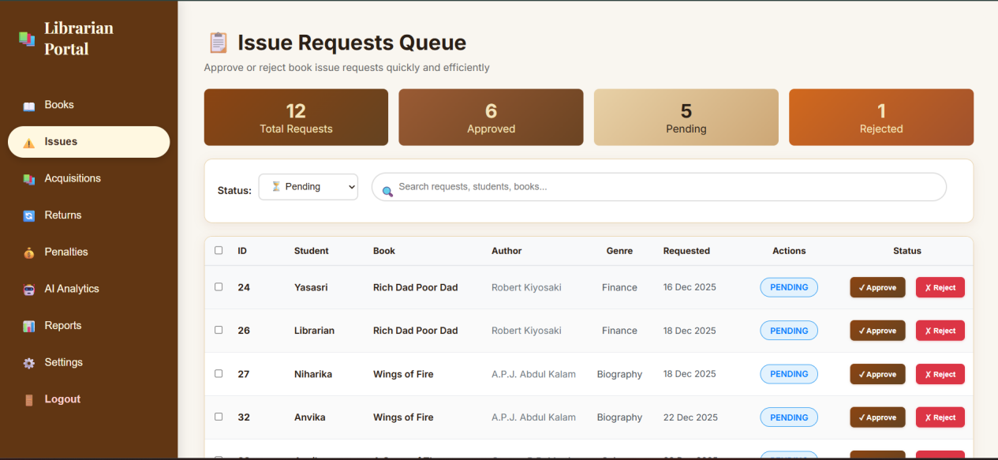

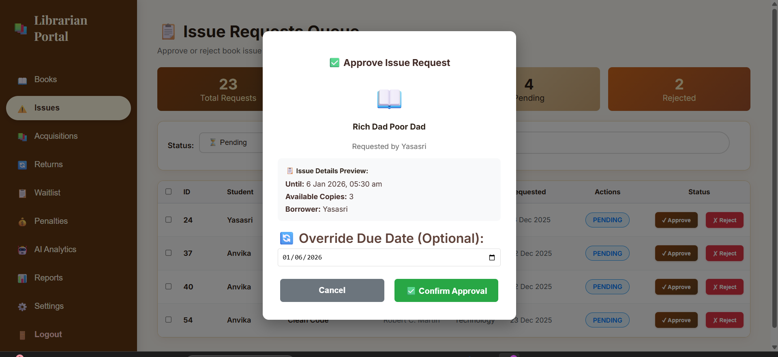

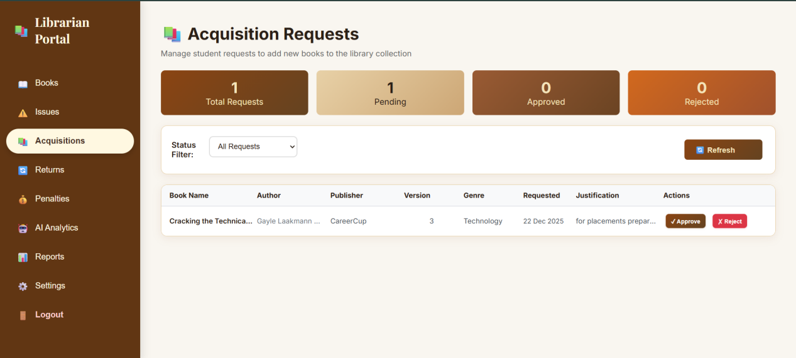

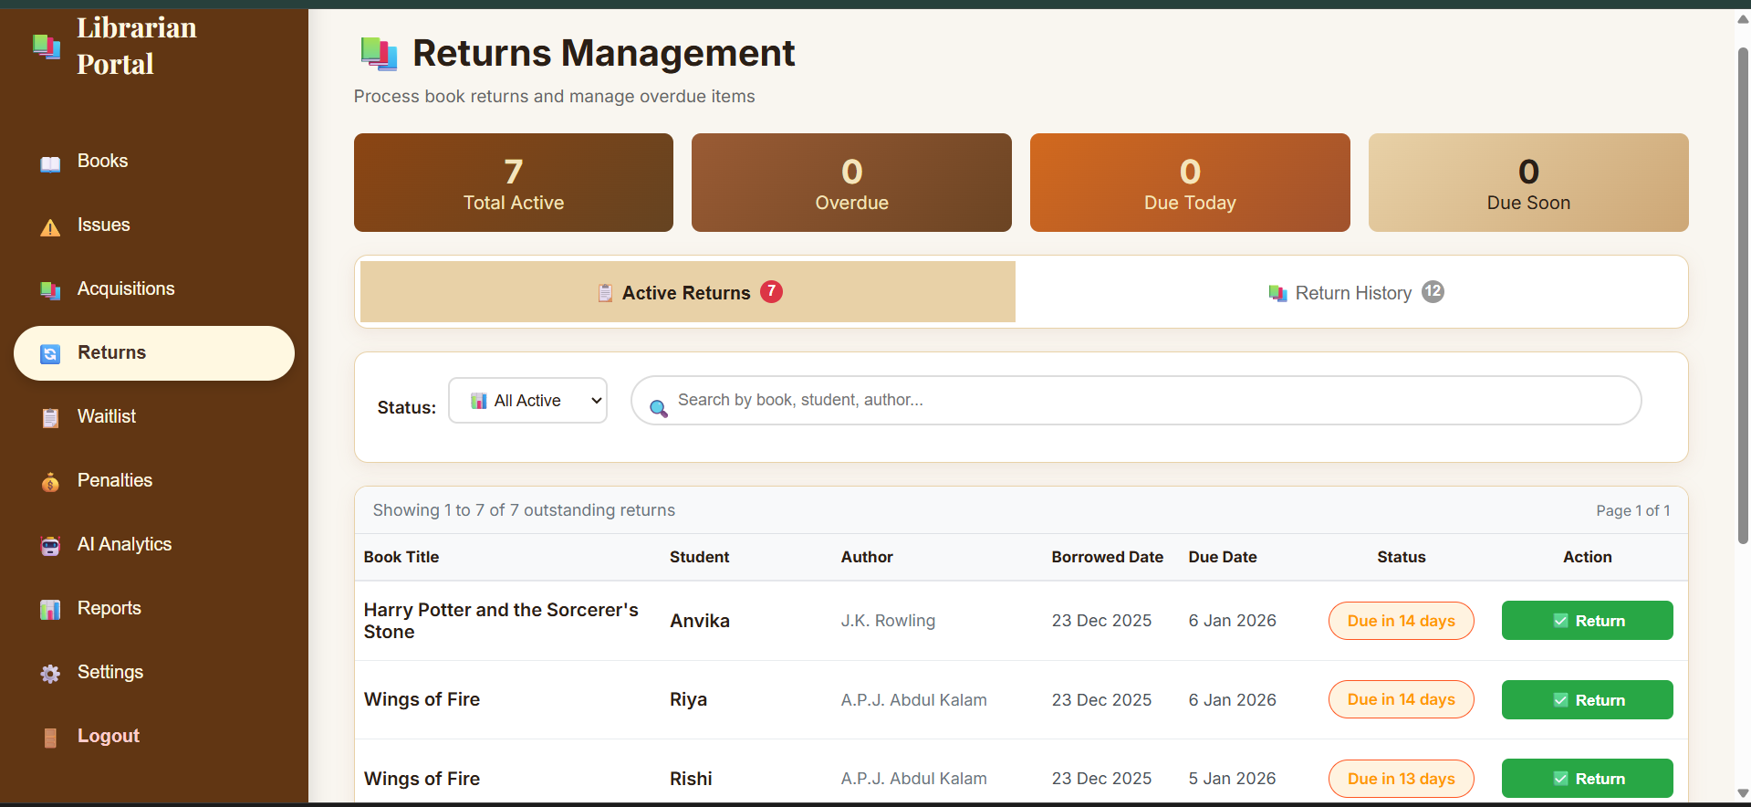

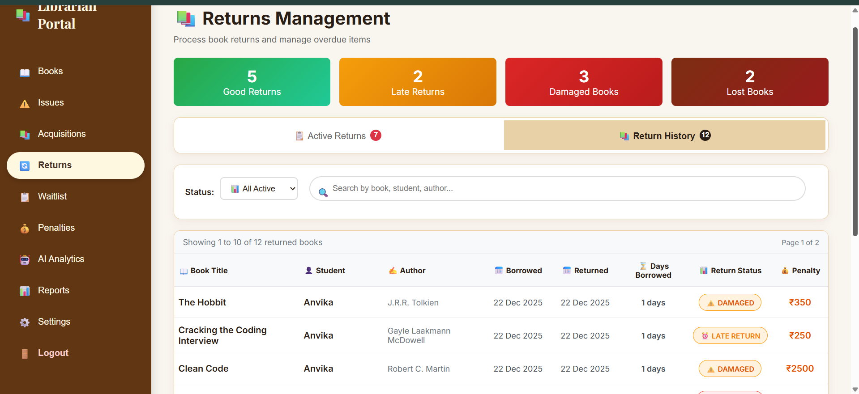

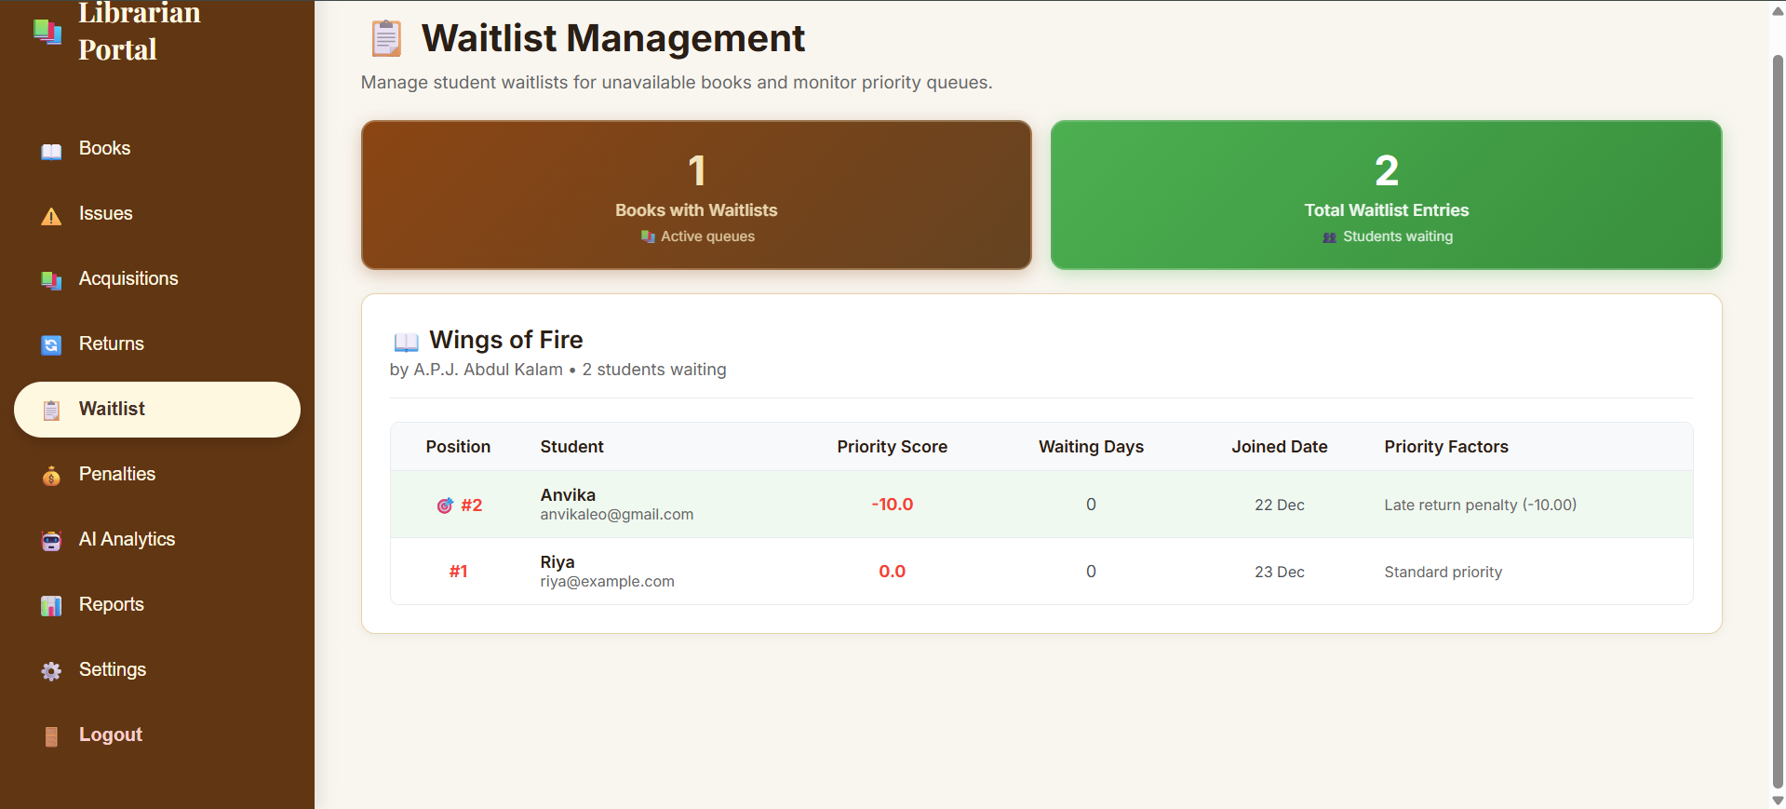

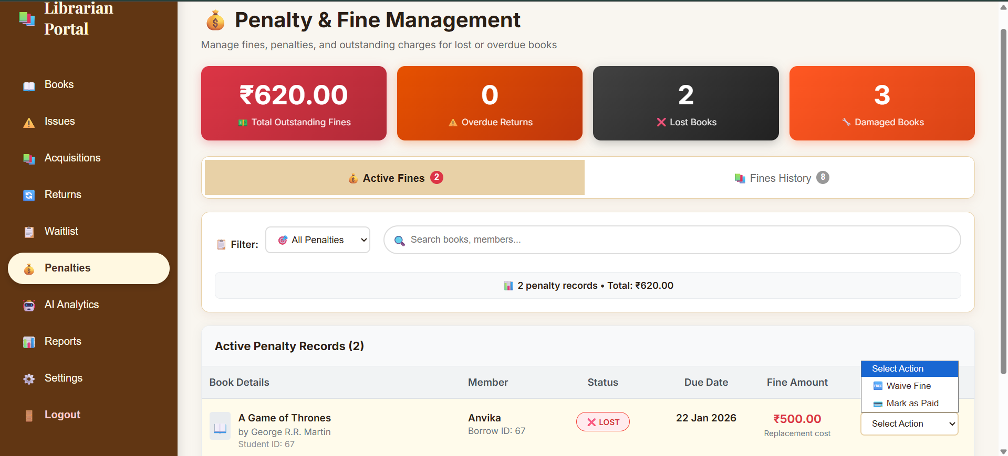

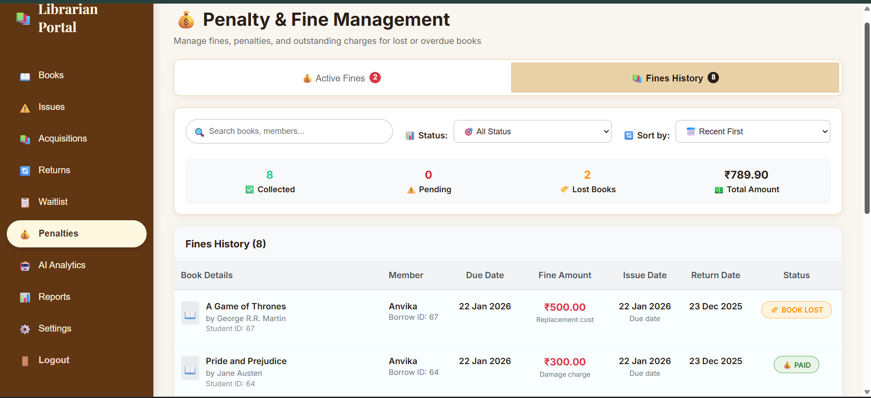

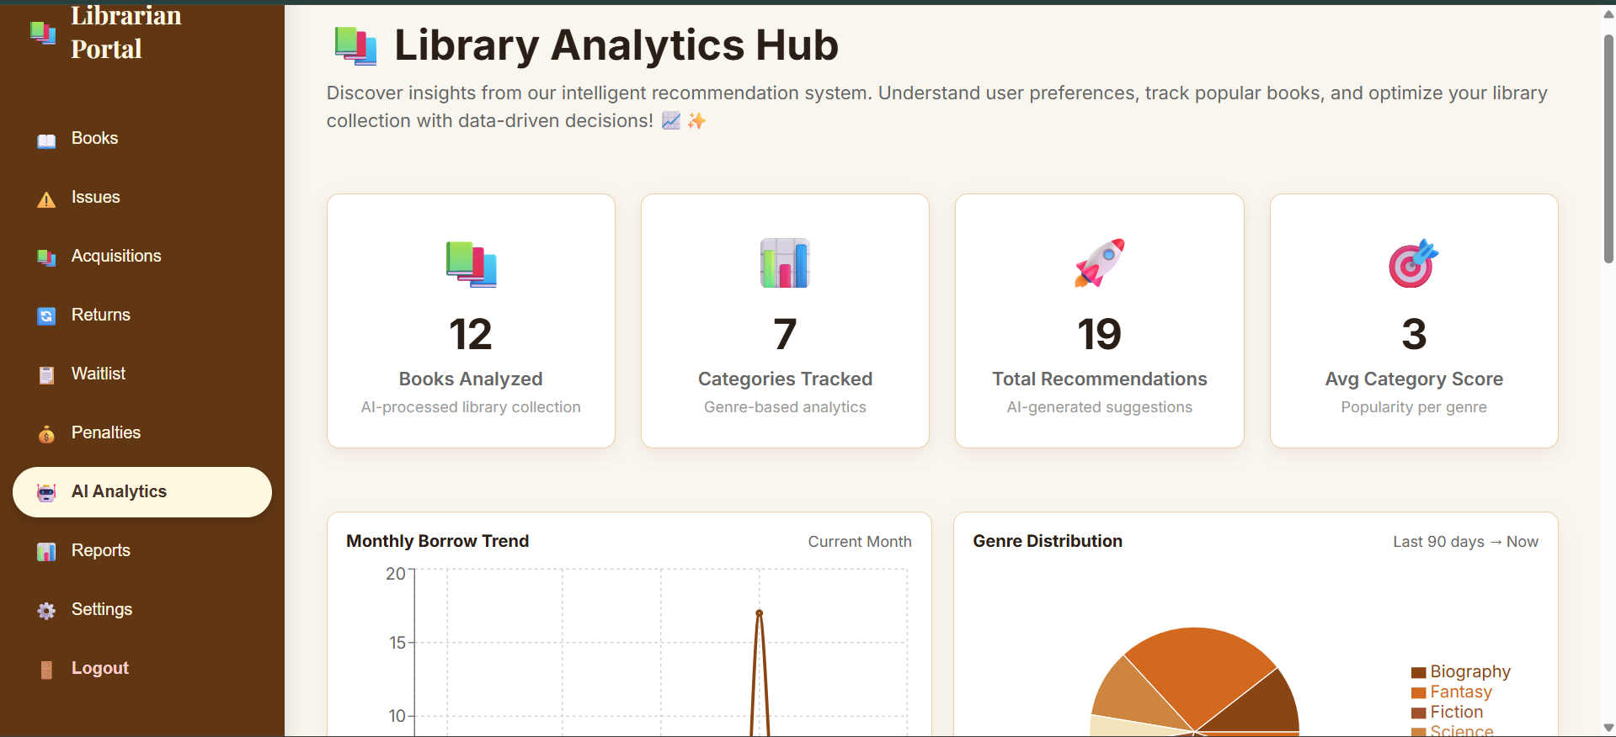

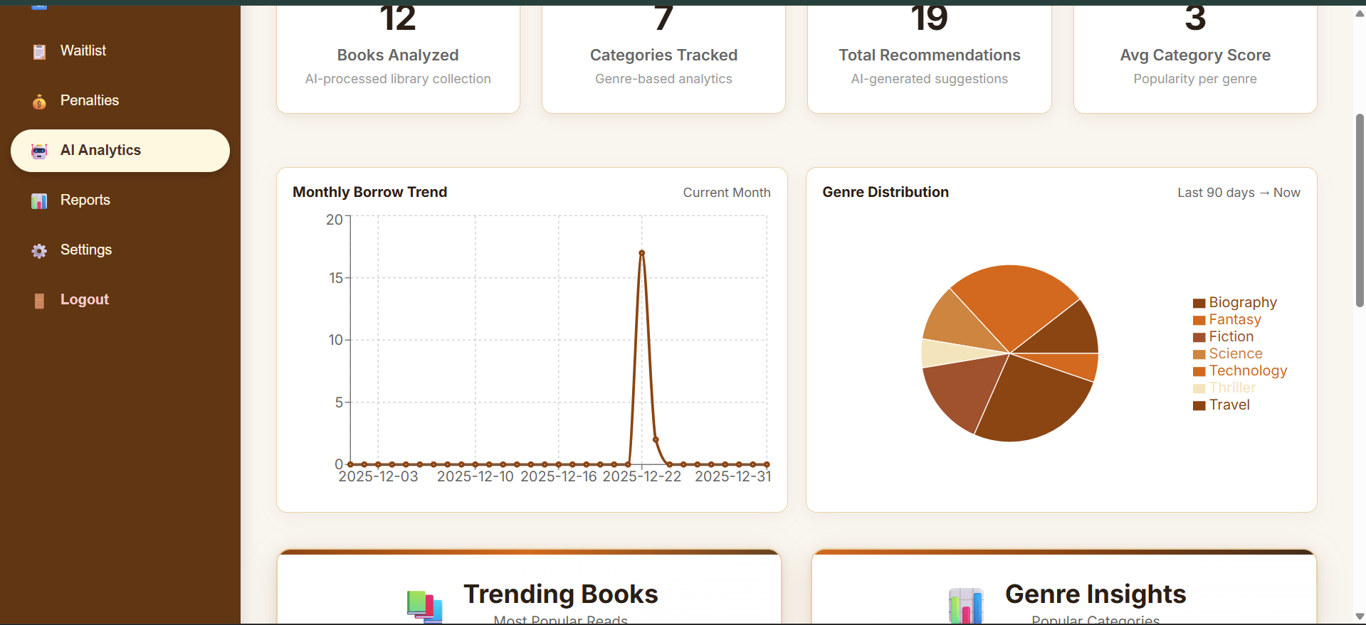

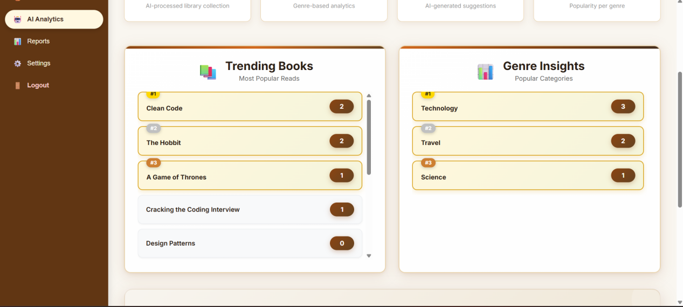

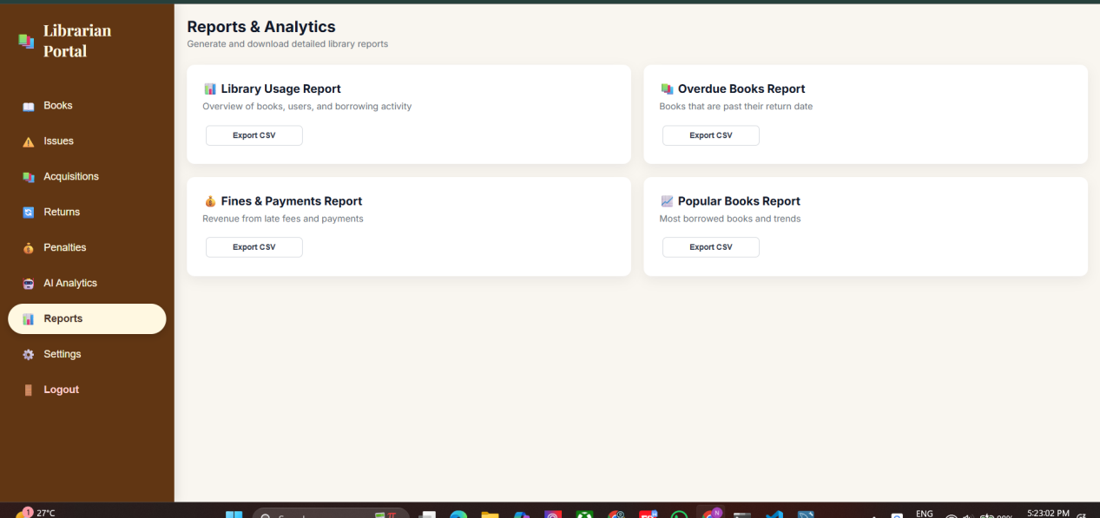

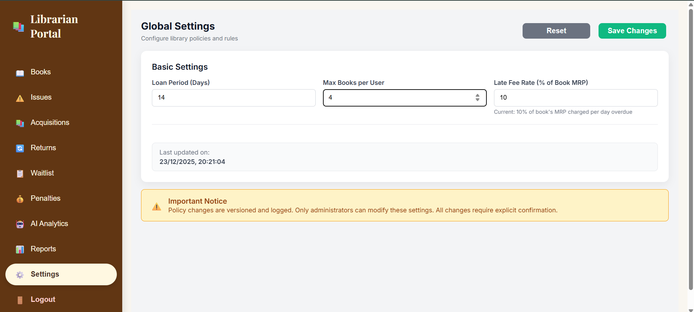

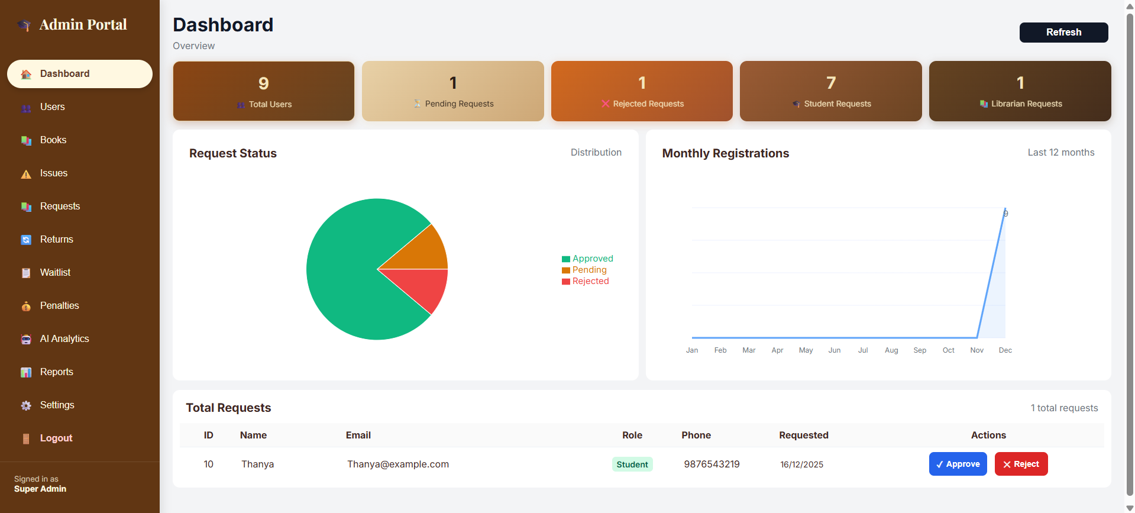

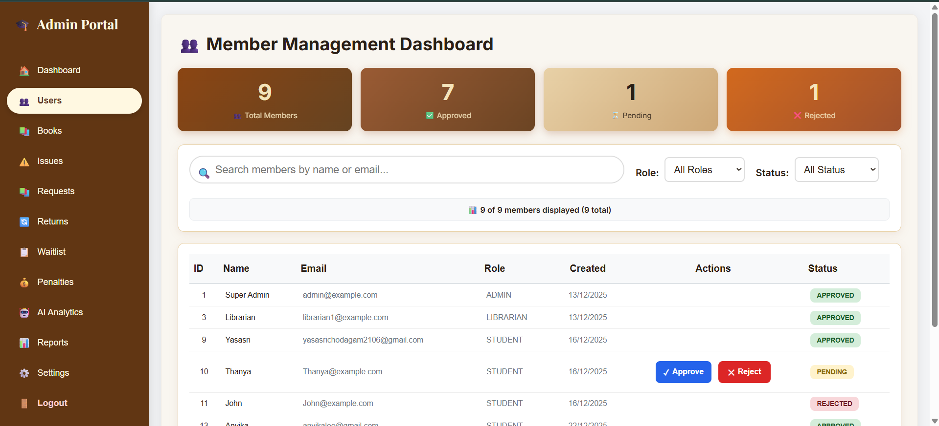

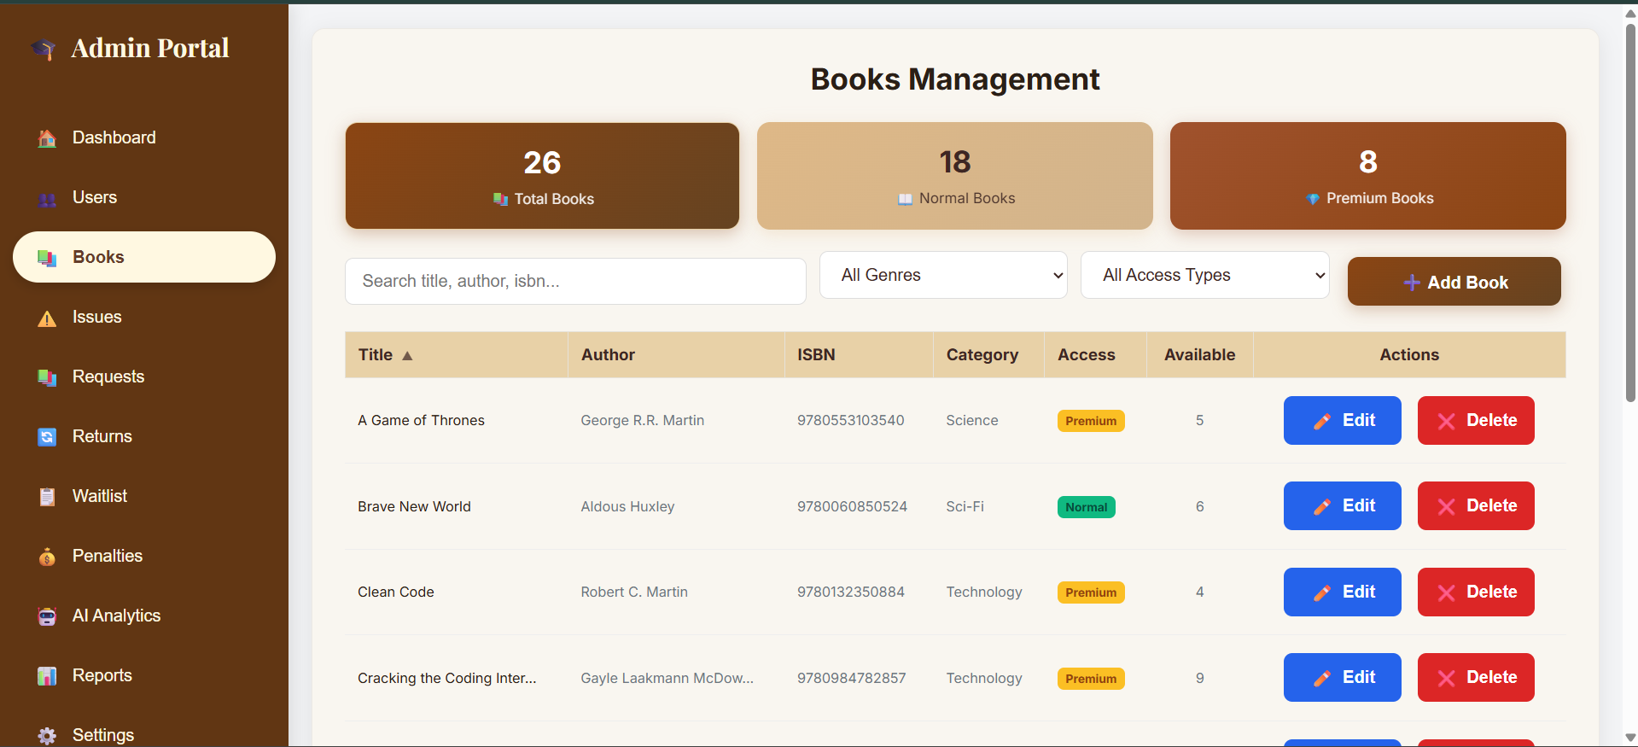

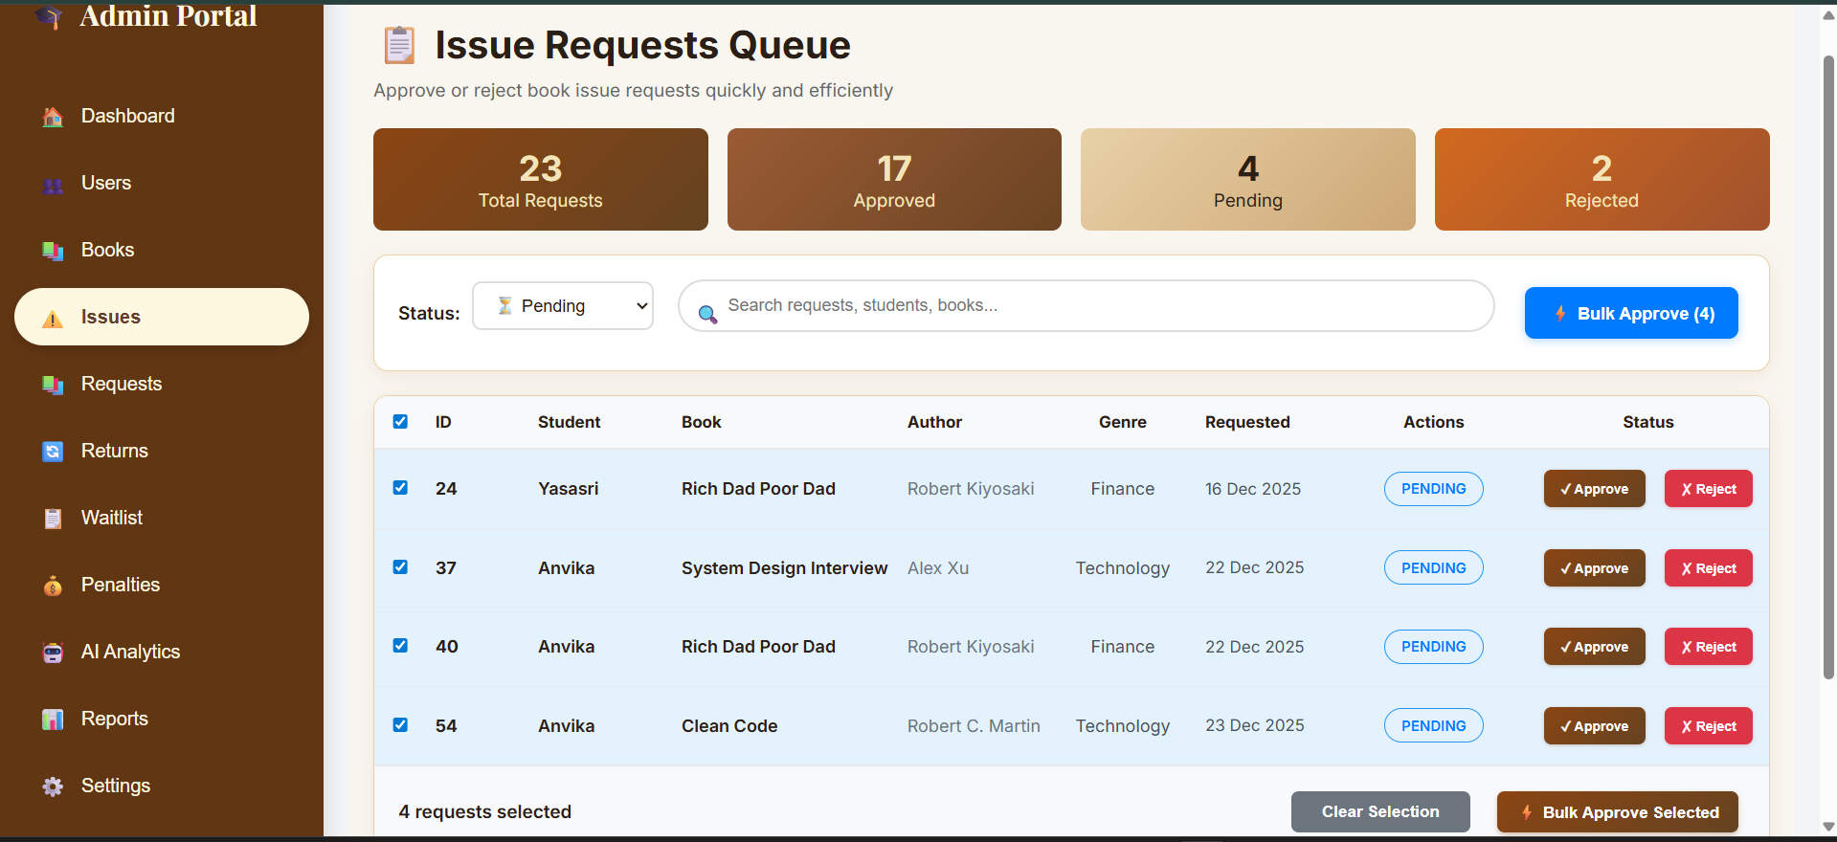

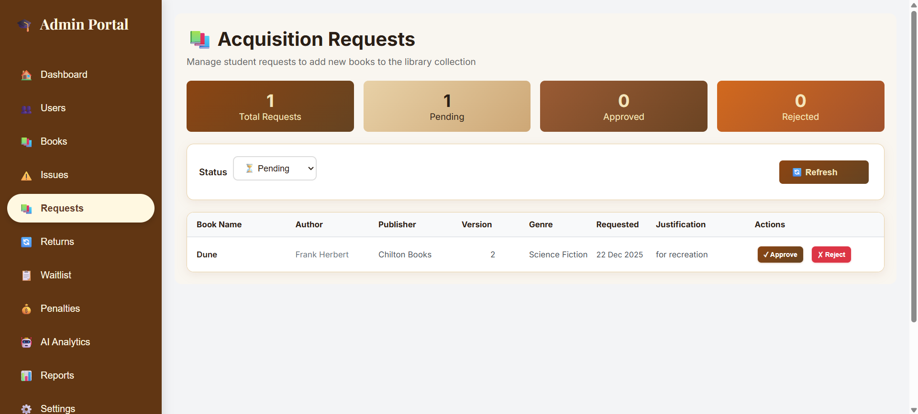

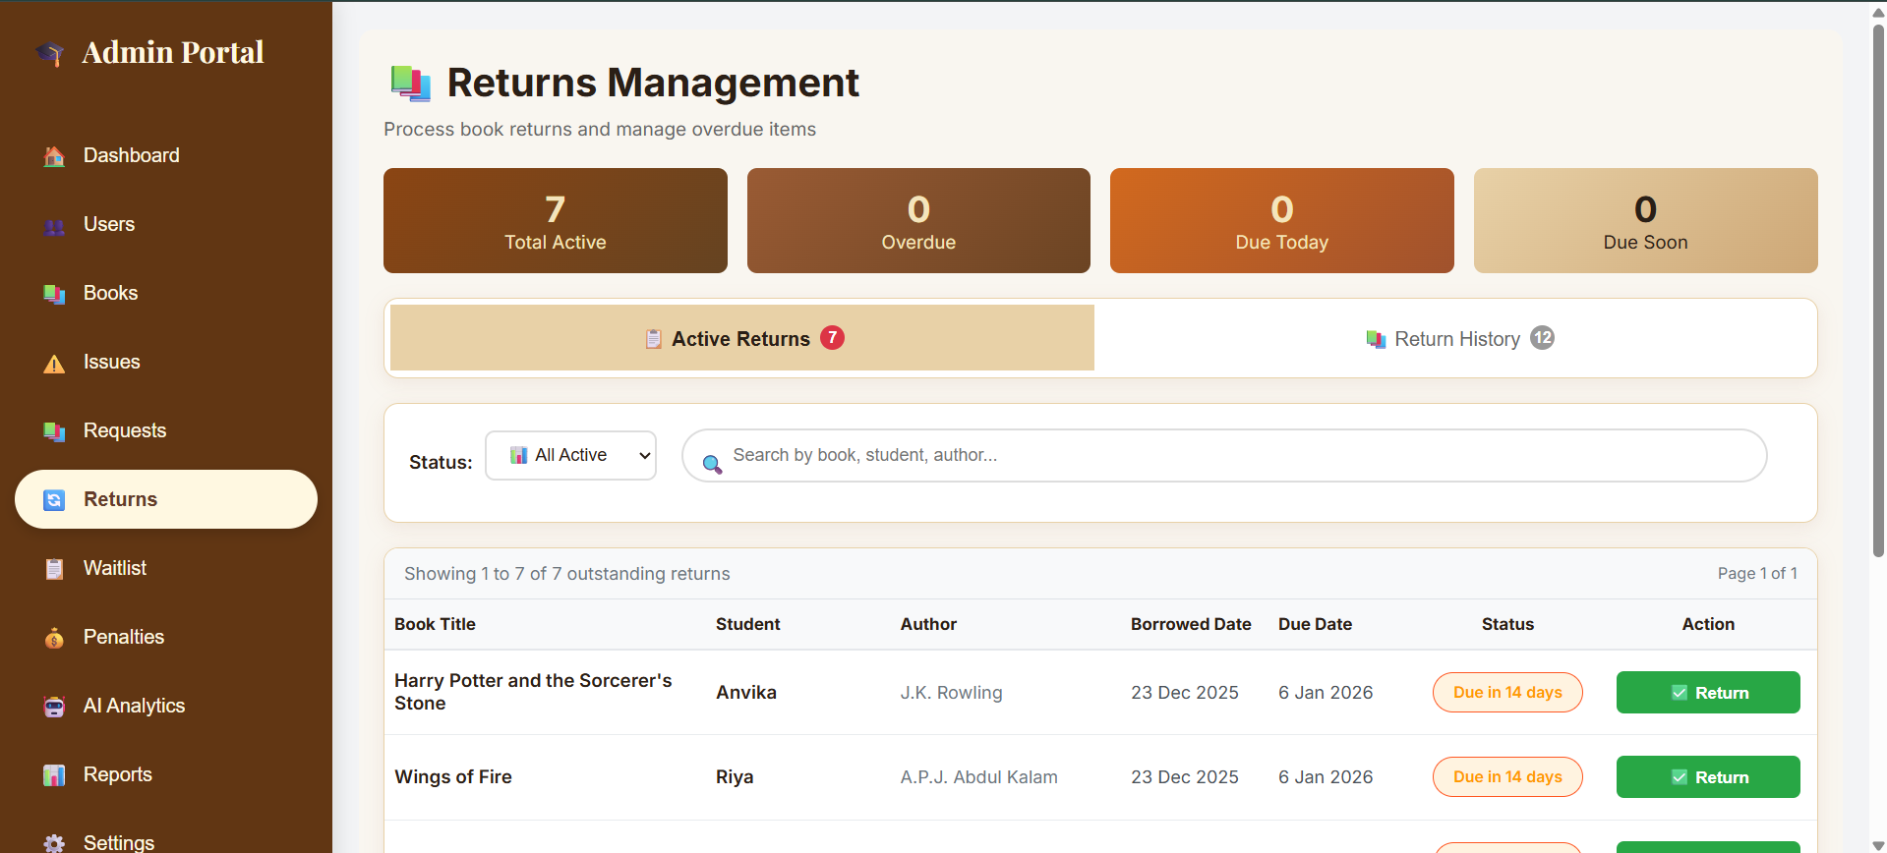

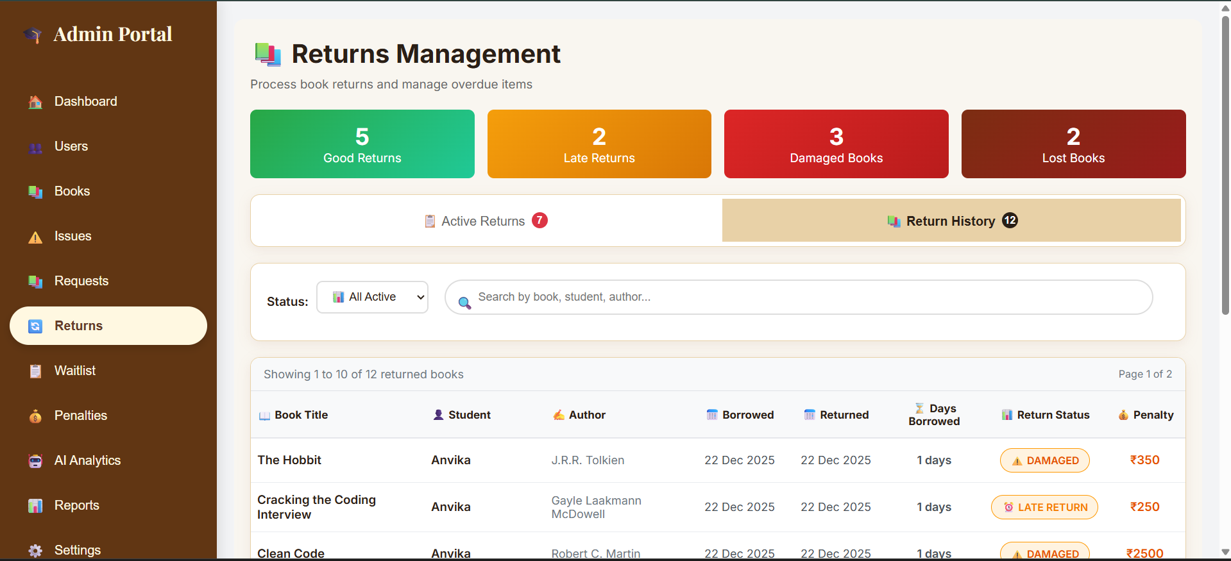

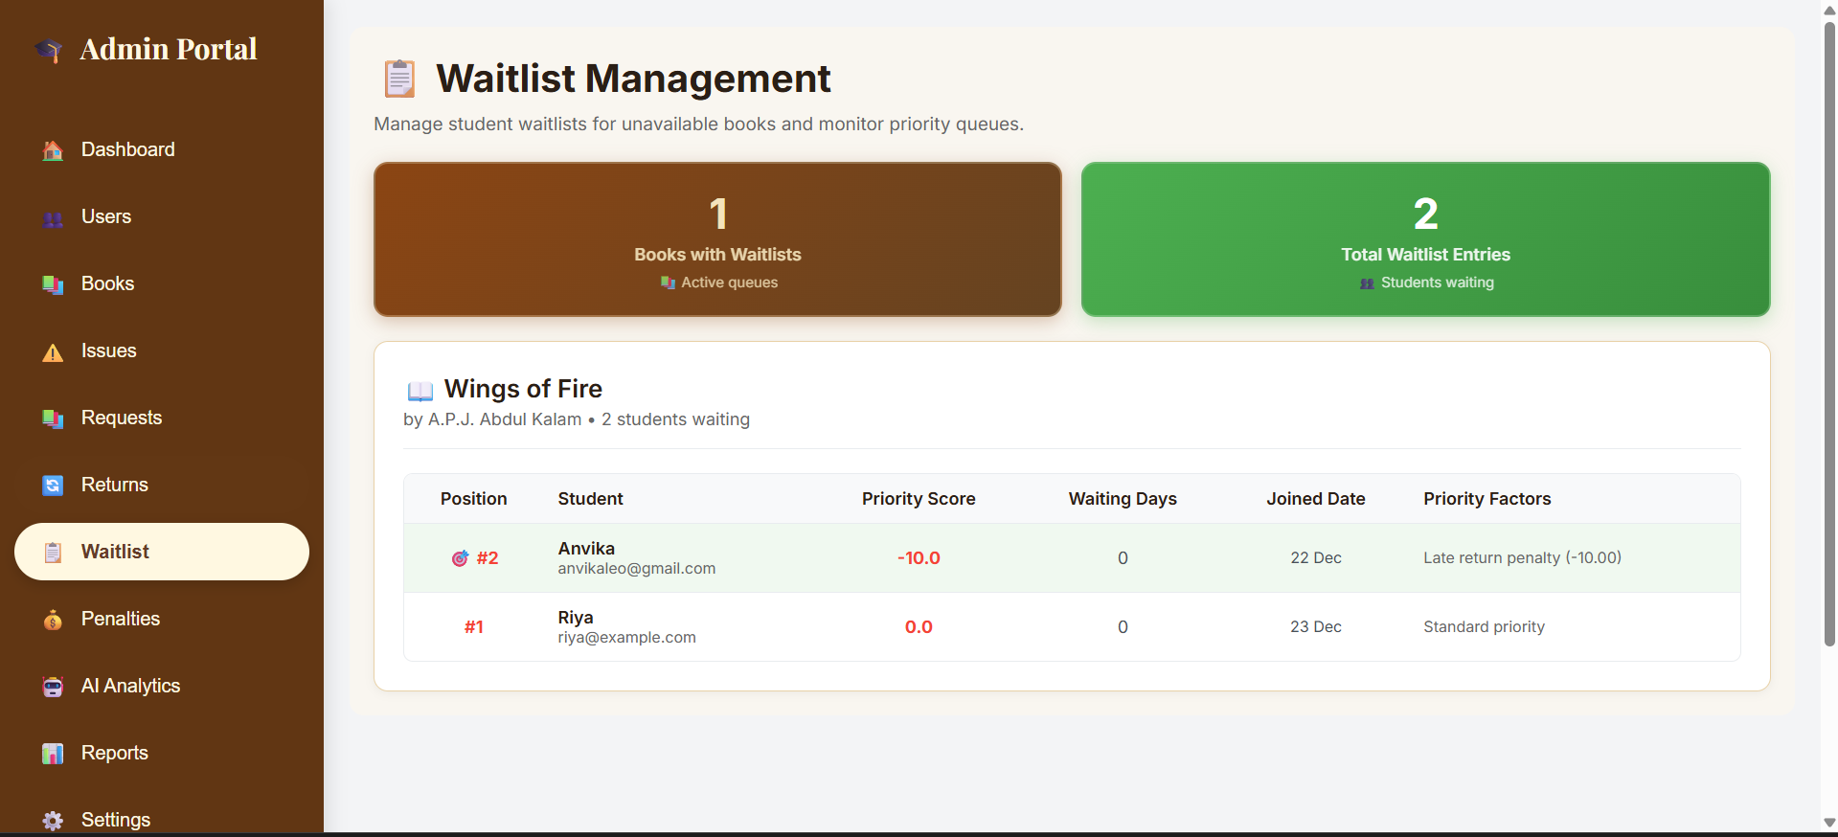

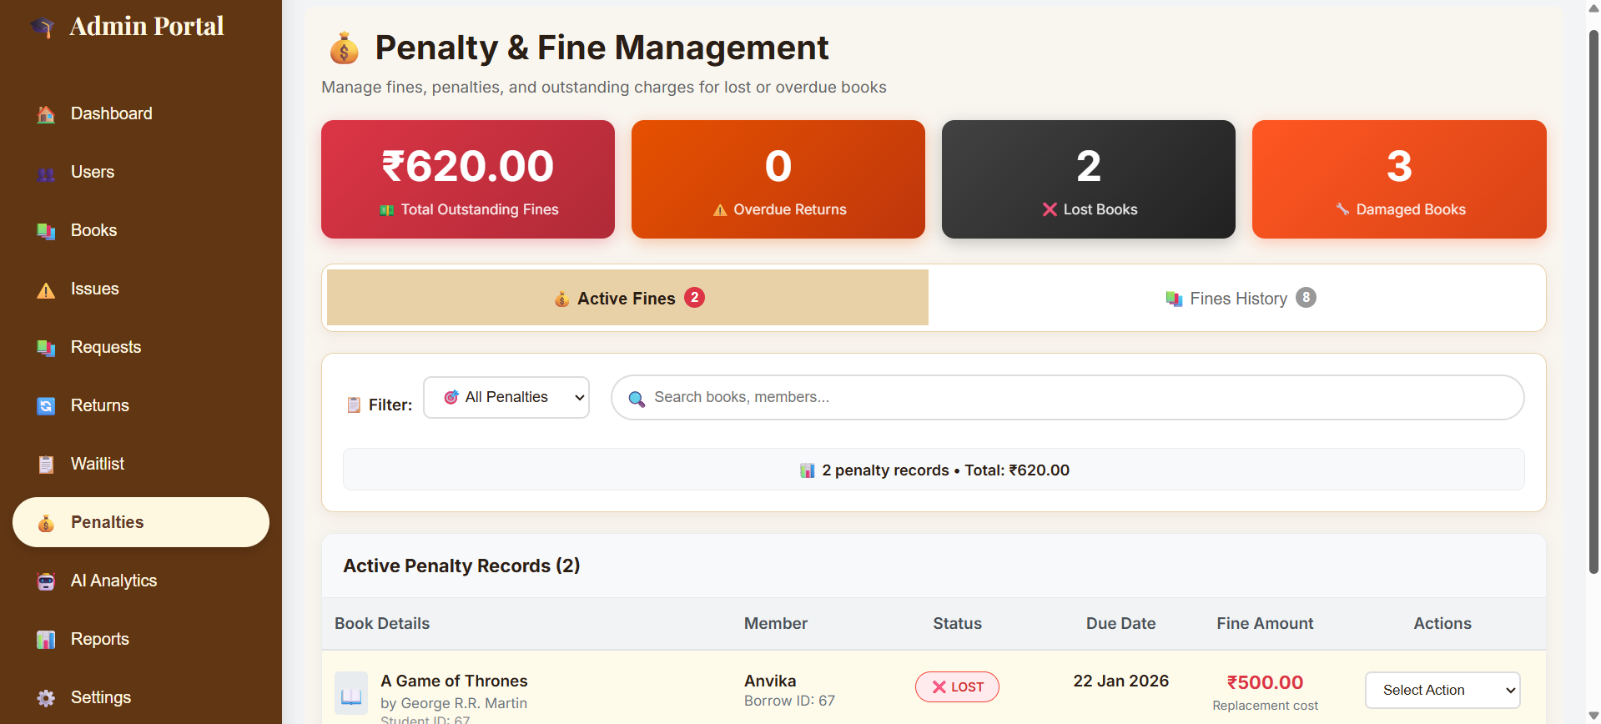

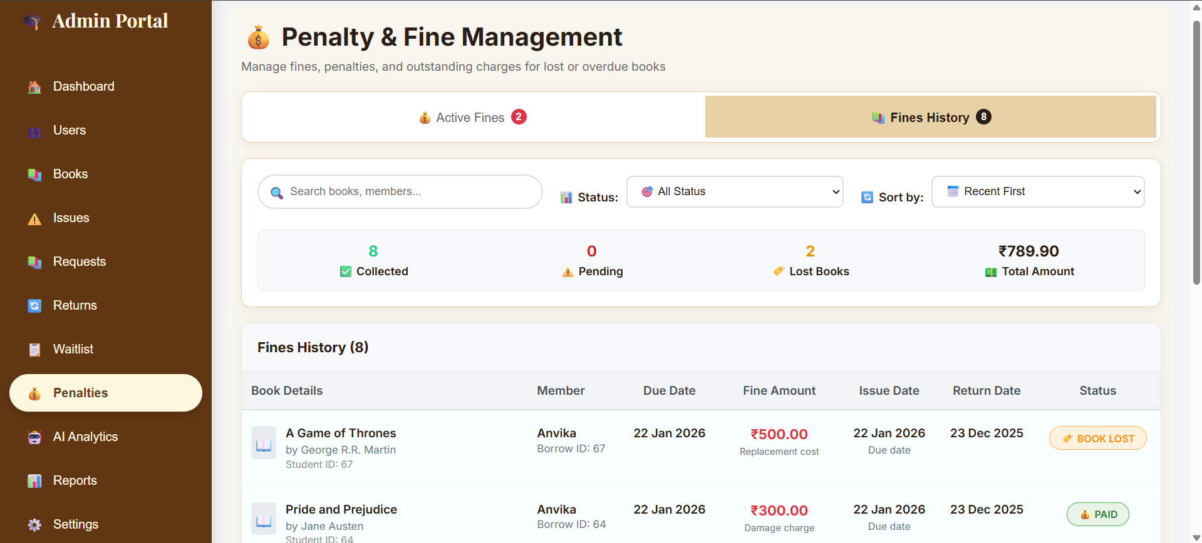

# 7. Challenges Faced

**Technical Challenges**

* Implementing calendar-based overdue logic
* Maintaining real-time inventory consistency
* Managing complex role-based permissions
* Integrating email services with templates

**Operational Challenges**

* Modeling real-world library workflows
* Ensuring data integrity across lifecycle
* Optimizing performance for large datasets
* Ensuring cross-browser UI consistency

**Resolution Strategies**

* Extensive research and testing
* Applying best practices and design patterns
* Database indexing and query optimization
* Comprehensive test coverage

# 8. Learnings & Skills Acquired

**Technical Skills**

* Full-stack development with React and Spring Boot
* MySQL database design and optimization
* REST API security and authentication
* TypeScript for scalable frontend development
* Git version control and collaboration

**Soft Skills**

* Problem-solving and analytical thinking
* Project planning and milestone tracking
* Technical documentation and communication
* Quality assurance and debugging

**Domain Knowledge**

* Library workflows and management systems
* User experience design for multi-role platforms
* Business process modeling
* Application security principles

# 9. Testimonials from team

This internship provided an excellent opportunity to work on a real-world application with modern technologies. The Library Management System project challenged me to think about complex business logic, user experience design, and system architecture. Building both frontend and backend components gave me a holistic understanding of full-stack development.

Working on calendar-based penalty calculations and real-time inventory management taught me the importance of accuracy in financial systems. The project helped me understand how to balance user experience with data integrity and implement complex business rules effectively.

# 10. Conclusion

This internship project successfully delivered a comprehensive Library Management System demonstrating modern web development practices and real-world problem-solving. The system provides an efficient and user-friendly platform for library operations while ensuring data accuracy and security.

The project strengthened my skills in React, Spring Boot, and database design, and enhanced my understanding of enterprise-level application development.

# 11. Acknowledgements

I sincerely thank the Infosys Springboard team for providing this internship opportunity. I would like to sincerely thank my mentor for his continuous guidance and support throughout the internship. His friendly approach and encouragement made learning smooth and enjoyable. The freedom he provided to explore and learn independently greatly improved my technical confidence. His practical insights played a key role in the successful completion of this project.I also thank my team members for their collaboration and shared learning